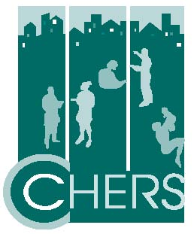

Center for Community Health Education Research and Service
25 Years Sustaining Partnerships for Innovations in Community Health

$ 5,000 Platinum Sponsor Recognition at event and a Full page Ad
$ 2,500 Gold Sponsor Recognition at event and a ½ page Ad
$ 1,250 Silver Sponsor Recognition at event and a ¼ page Ad
$ 500 Bronze Sponsor Name listed in the Program
$ 250 Patron Name listed in the Program

Company/Business Name: ____________________________________________________________________

Contact Name: _____________________________________________________________________________

Address: __________________________________________________________________________________

Telephone/Fax: ____________________________________________________________________________

Email: ____________________________________________________________________________________

To be included in the program book, forward your Ad by Friday, November 4th to:

Center for Community Health Education Research and Service
360 Huntington Avenue, 222 HH
Boston, Massachusetts 02115

Please make checks payable to CCHERS, Inc.

Please submit your Ad Copy by November 4th

Sorry I/we cannot attend the event but would like to make a contribution of $_____________
If your organization provides matching funds please check here. ________

